Project outline: Memories of Fiction

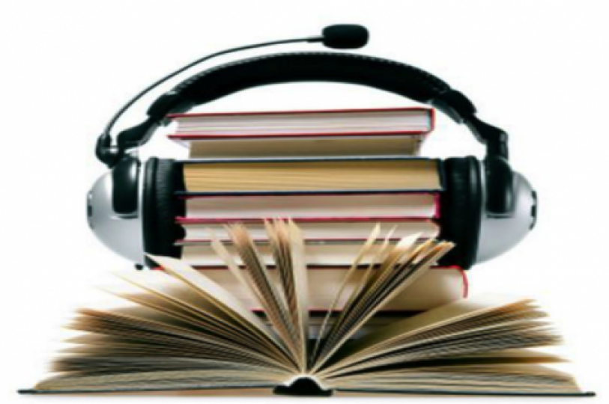
Project team: Amy Tooth Murphy,
Shelley Trower, and Graham Smith
(University of Roehampton and
Royal Holloway, University of London)

Dates: July 2014 – July 2017

Funding: Arts & Humanities Research Council

Website: www.memoriesoffiction.org

Summary:
What do we remember about the books we have read – from childhood onwards – and why? The project is interested in both individual and collective memories of reading fiction. It will first set up an oral history archive of interviews with members of reading groups, to explore memories as described in individual life stories. In doing so, the project will provide a new kind of resource - differing from the numerous interviews carried out with authors, from oral history interviews (archived with the British Library’s 'Authors' Lives' project), to radio and other interviews by journalists, fans and other readers. By turning to readers themselves, the project will make available new material.

One thing that is interesting about reading groups is that they turn written text into group talk. After the individual interviews, the project researchers will thus work in the reading groups. Having identified clusters of books recalled across a number of interviews, these books, and memories of them, will then be discussed in groups. Free books will be provided! We are interested in how these shared memories compare to individual recollections. In what ways can group talk change how we remember fiction?

Schedule:
We hope to complete the interviews in the first year of the project (by next summer), and then to begin the work in the groups.

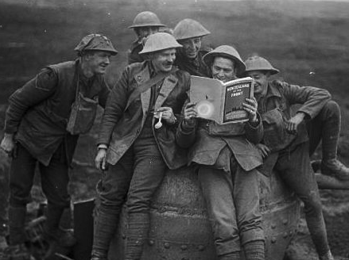
Outputs: Outputs will include the archive of oral history interviews, group discussions, and public talks (approx. 30-40 interviews plus 10-20 from the PhD student, 3-6 group discussions, 3-4 public talks), websites, publications, seminars, public talks, and a conference.

Partners: Wandsworth Heritage Service
Reading Experience Database: www.open.ac.uk/Arts/RED/

